**CADENAS Partners With Onshape, the First Full-Cloud Professional 3D CAD System**

Software specialist now offers Onshape users access to manufacturer catalogs

**Germany, Augsburg, 6th July 2016.** CADENAS, a leading software developer in the areas of Strategic Parts Management, parts reduction (PARTsolutions), and Electronic Product Catalogs (eCATALOGsolutions), has fully integrated its millions of part models into Onshape, a new cloud-based CAD system that runs on any computer, tablet or phone.

Engineers, designers and builders can now access over 400 3D CAD manufacturer catalogs for free from directly within Onshape. In 2015, CAD users have imported more than 152 million 3D CAD models from the CADENAS 3D CAD models download portal PARTcommunity.

CAD users can select their desired part models directly in Onshape, and integrate them into their design within an Onshape assembly. Access to CADENAS 3D CAD manufacturer catalogs is enabled through the deep integration of the 3D CAD download portal PARTcommunity by CADENAS.

“As an Innovation Company, CADENAS is constantly striving to incorporate new approaches and technologies into our products,” says Walter Leder, COO of the CADENAS GmbH. “We love to cooperate with companies that revolutionize the market and with Onshape we have the perfect partner.”

“We’re delighted to integrate CADENAS parts into Onshape and give our customers millions of more choices of parts and components when designing their products,” says Darren Henry, Onshape’s Director of Marketing. “Onshape is all about speeding up the design process and we’re confident our community will value the additional time savings from having instant access to these models.”

Onshape, which runs in a web browser or mobile app (Android and iOS), is especially designed for teams. It is the first professional 3D CAD system to enable multiple people to simultaneously work on the same model.

If users already have the Onshape app, they just have to go through it: In their documents is an own tab where they get access to 3D CAD manufacturer catalogs by CADENAS. Users, who don’t have Onshape app, have to subscribe the app once [https://appstore.onshape.com](https://appstore.onshape.com/) to get access afterwards.

[Users can create their free Onshape Account!](https://www.onshape.com/onshape-manifesto-par?utm_campaign=cadenas-comarketing&utm_medium=sign-up&utm_source=co-marketing)

**Press Images:**

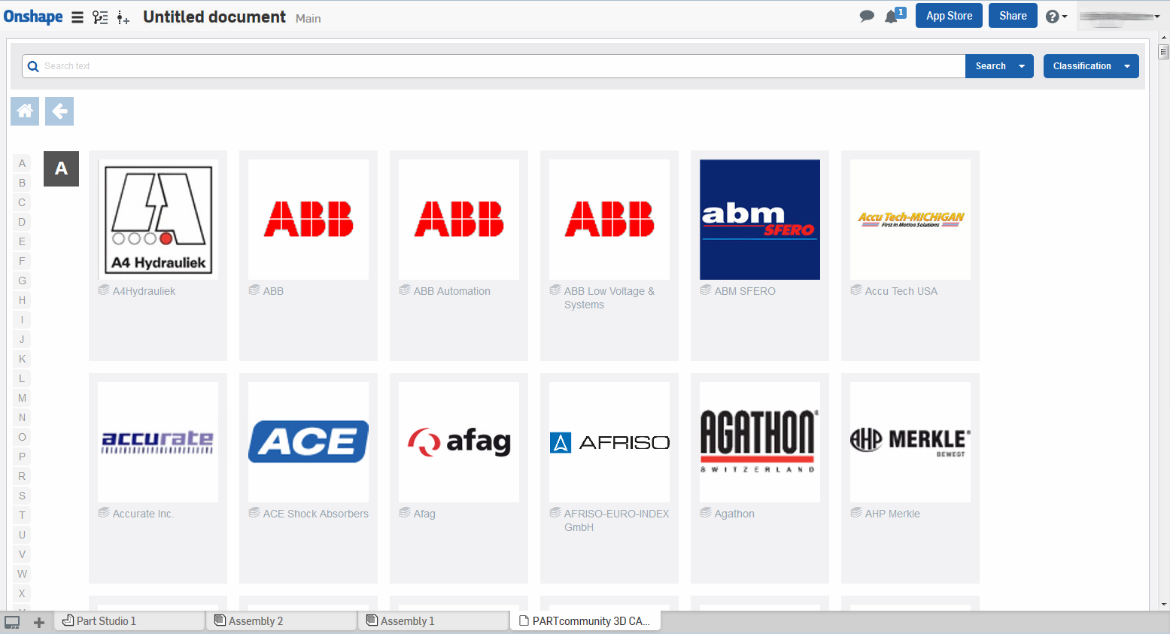

**Caption 1:** CAD users can select their desired part models directly in Onshape, and integrate them into their design within an Onshape assembly.

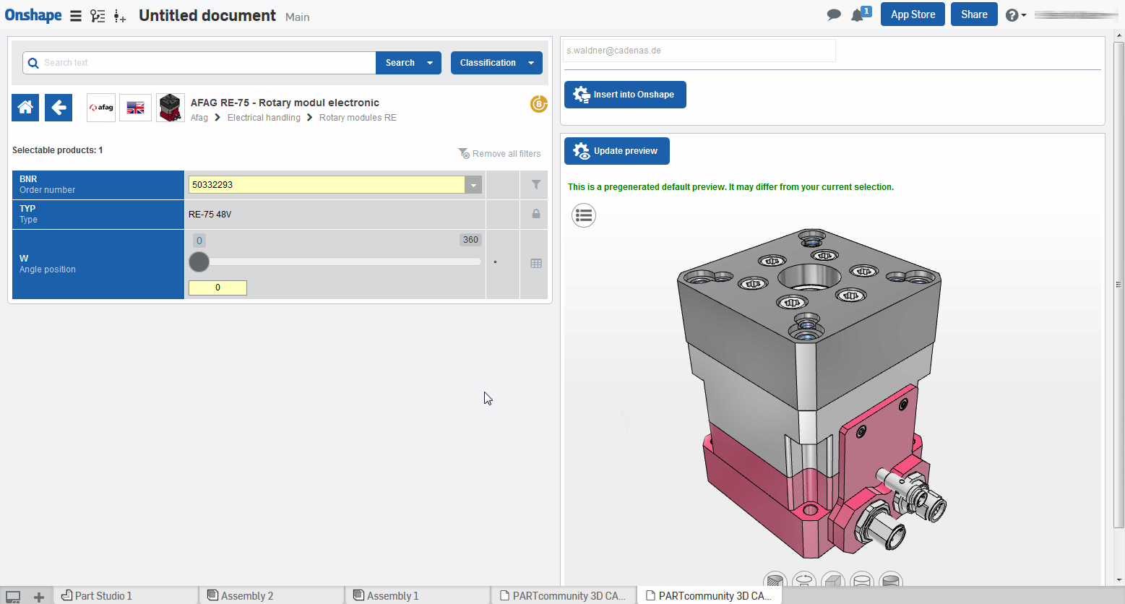

**Caption 2:** Access to CADENAS 3D CAD manufacturer catalogs is enabled through the deep integration of the 3D CAD download portal PARTcommunity by CADENAS.

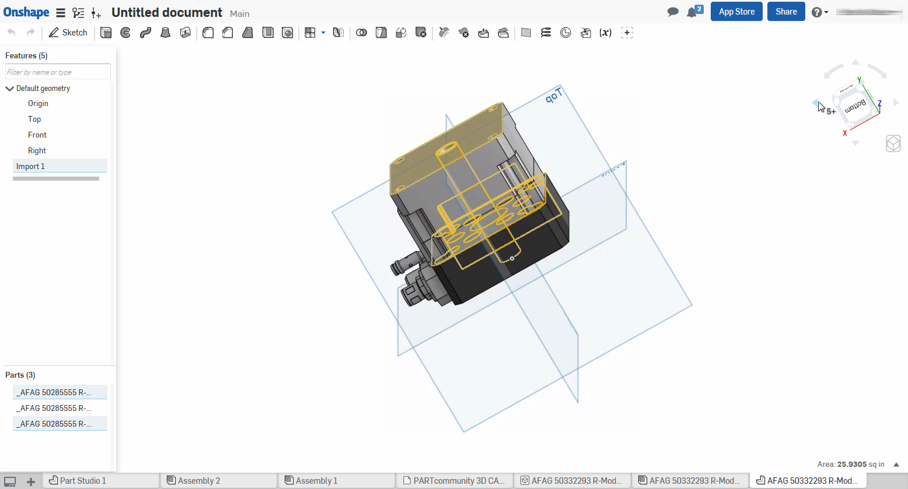

**Caption 3:** Onshape, which runs in a web browser or mobile app (Android and iOS), is especially designed for teams.

This press release and accompanying images are available for download from our website: [www.cadenas.de/press/press-releases](http://www.cadenas.de/press/press-releases)

**About CADENAS**

CADENAS is a leading software developer in the areas of Strategic Parts Management and parts reduction (PARTsolutions), as well as Electronic Product Catalogs (eCATALOGsolutions). With its customized software solutions, the company acts as a link between the component manufacturers with their products and the purchasers.

With its 300 employees at 17 international subsidiaries, the name CADENAS (Hispanic: process chains) has been standing for success, creativity, support and process optimization since 1992.

For further information, please visit: www.cadenas.de/en